**Nama : Mualif Dwi Saputra  
NIM : 18090043  
Kelas : 5A**

1. **Source Code**Web.php -> application/controllerv_header.php -> application/viewv_index.php -> application/viewv_footer.php -> application/viewv_about.php -> application/viewstylebook.css -> assets/css
2. **URL**

<http://localhost/mualif/web>

<http://localhost/mualif/web/about>

1. **Capture Hasil**

**web**

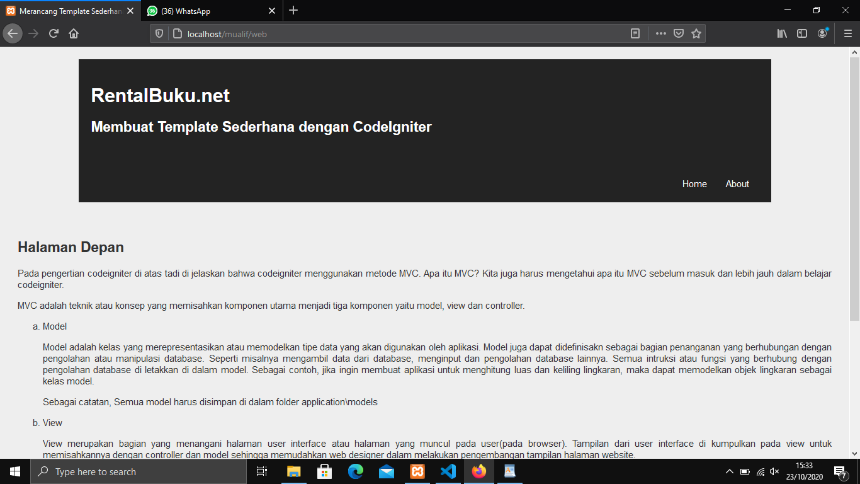

**web/about**

